ASSIGNMENT-05

1. Add constraint : DeptCode of Student is foreign key with reference to DeptCode in Department.
ALTER TABLE STUDENT2063 ADD CONSTRAINT FK_STUDENT FOREIGN KEY (DEPTCODE) REFERENCES DEPARTMENT(DEPTCODE);
Select table_name,constraint_name,constraint_type,search_condition from all_constraints where table_name='STUDENT2063';
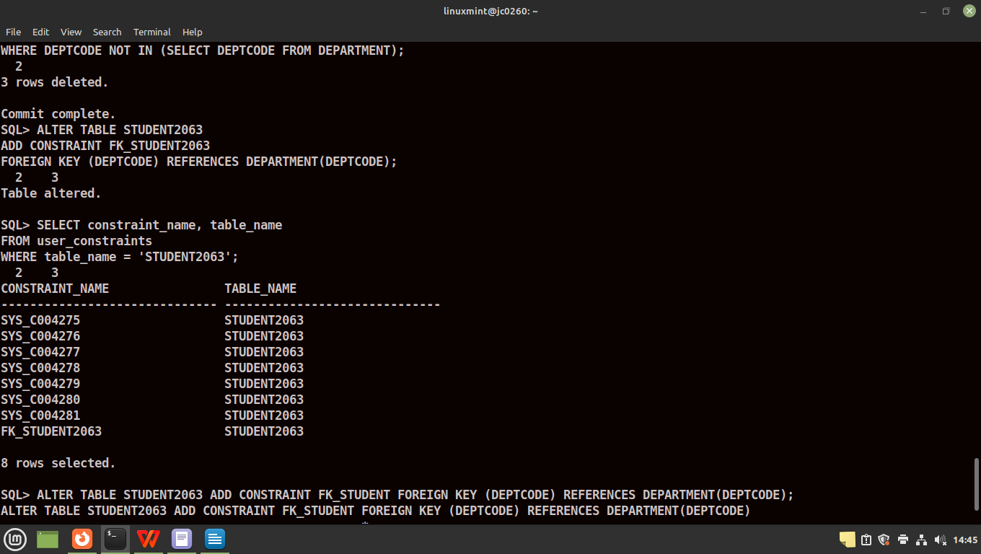

2. Add an attribute Block to the department table (data type - Char).
ALTER TABLE DEPARTMENT2063 ADD BLOCK CHAR;
DESC DEPARTMENT2063;
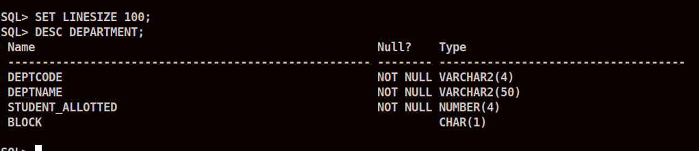

3. Insert data to this attribute.
UPDATE DEPARTMENT2063 SET BLOCK ='C' WHERE DEPTCODE='CSE' OR DEPTCODE='IT';
UPDATE DEPARTMENT2063 SET BLOCK ='B' WHERE DEPTCODE ='ECE' OR DEPTCODE ='EE';
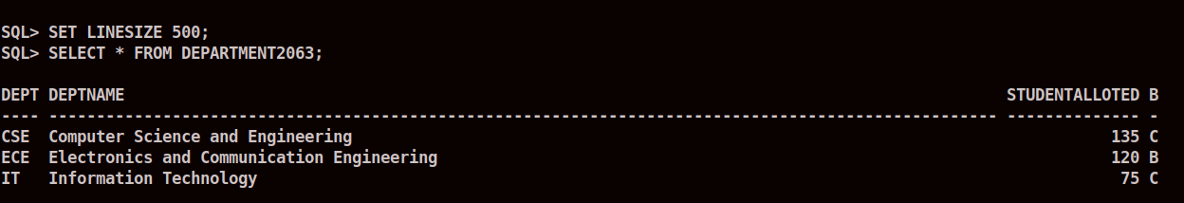

4. Increase the width of the column subject code of SUBJECT table to 8.
ALTER TABLE SUBJECT MODIFY SUBJECTCODE VARCHAR(8);
DESC SUBJECT;

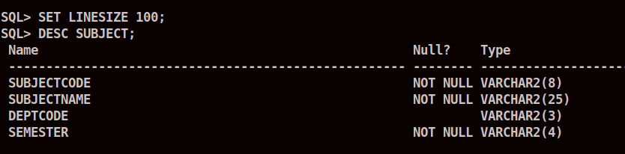

5. Delete primary key of table of Subject.
ALTER TABLE SUBJECT2063 DROP PRIMARY KEY;
Select table_name,constraint_name,constraint_type,search_condition from all_constraints where table_name='SUBJECT2063';

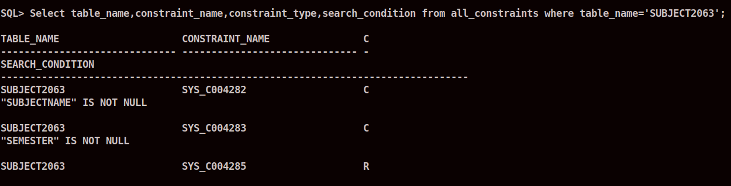
6. Add primary key to the table subject.
ALTER TABLE SUBJECT2063 ADD CONSTRAINT PK_SUBJECT PRIMARY KEY(SUBJECTCODE);
Select table_name,constraint_name,constraint_type,search_condition from all_constraints where table_name='SUBJECT2063';

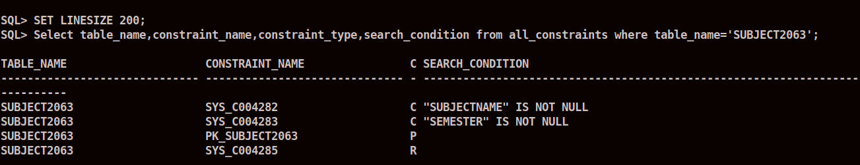
7. Make Sub_code of Result table foreign key with respect to Subject code of SUBJECT table.

ALTER TABLE RESULT2063 ADD CONSTRAINT FK_RESULT2063 FOREIGN KEY(SUB_CODE) REFERENCES SUBJECT2063(SUBJECTCODE);
Select table_name,constraint_name,constraint_type,search_condition from all_constraints where table_name='RESULT2063';

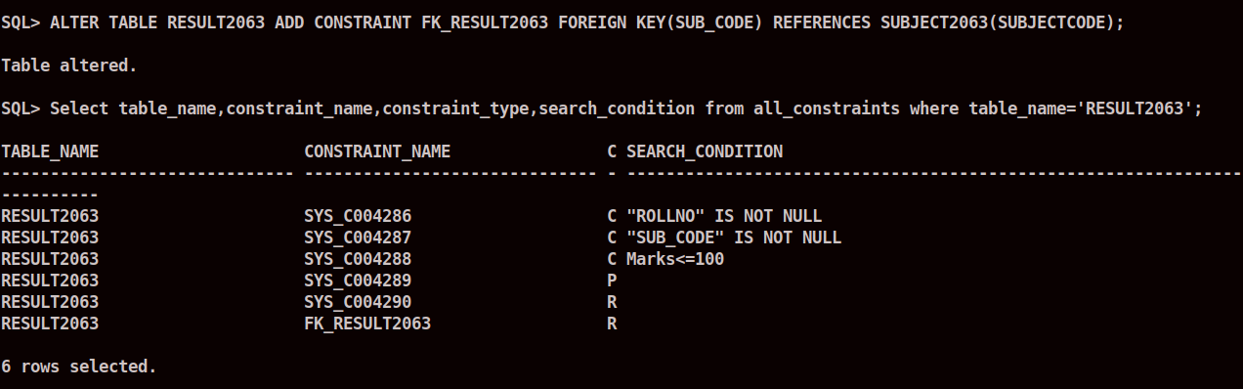

8. Add constraint that marks cannot be negative.
ALTER TABLE RESULT2063 ADD CONSTRAINT CHK_RES2063 CHECK (MARKS >= 0);
Select table_name,constraint_name,constraint_type,search_condition from all_constraints where table_name='RESULT2063';
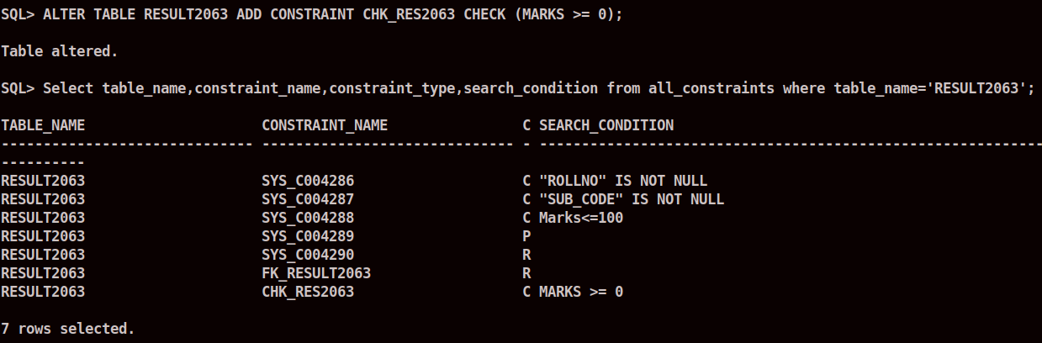
9. Alter the table SUBJECT and add check constraint such DeptCode is either CSE,IT, MCA, EE, ECE.
ALTER TABLE SUBJECT2063 ADD CONSTRAINT CHK_DEPT2063 CHECK (DEPTCODE='CSE' OR DEPTCODE='IT' OR DEPTCODE='MCA' OR DEPTCODE='EE' OR DEPTCODE='ECE');
Select table_name,constraint_name,constraint_type,search_condition from all_constraints where table_name='SUBJECT2063';
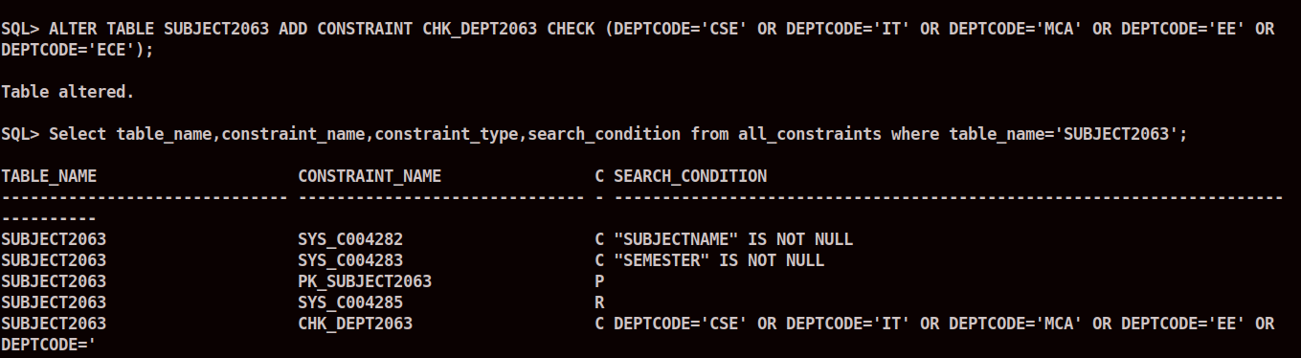
10. Add column college phone number and add phone number 25739607 to each student.

ALTER TABLE STUDENT2063 ADD COLLEGE_PHONE_NO NUMBER(10) DEFAULT 25739607;
SELECT * FROM STUDENT2063;
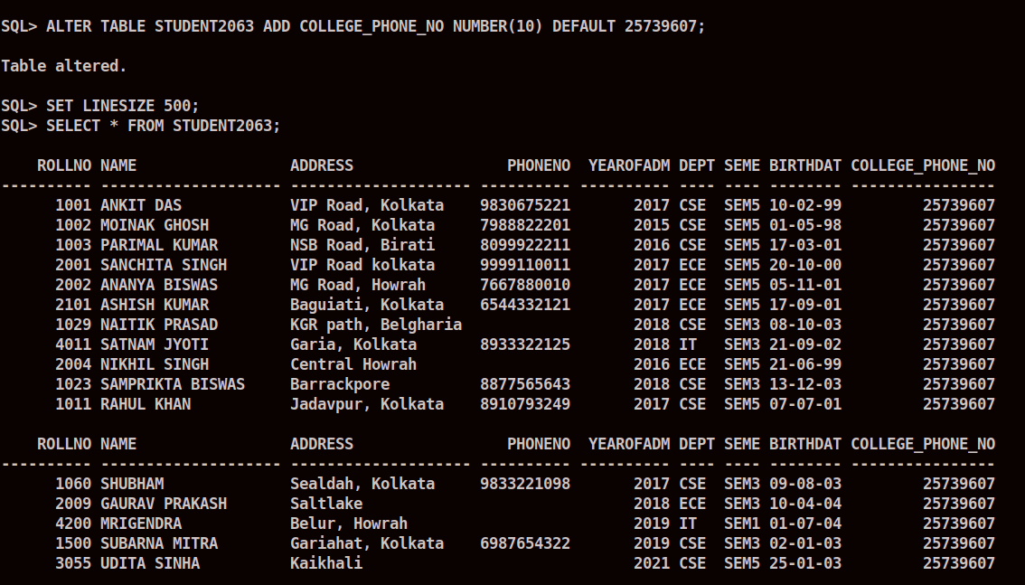
11. Create a table FACULTY (FID VARCHAR2(4), Name VARCHAR2(20)); Faculty id should start with ‘F’.
CREATE TABLE FACULTY2063(FID VARCHAR2(4),NAME VARCHAR2(20),CONSTRAINT CHK_FAC2063 CHECK (FID LIKE 'F%'));
DESC FACULTY2063;
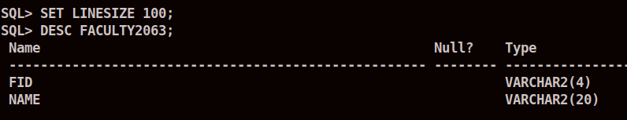
12.Insert values to the table Faculty.
INSERT INTO FACULTY2063 VALUES('F01','Aloke Kumar Dutta');
INSERT INTO FACULTY2063 VALUES('F02','Abhijit Roy');
INSERT INTO FACULTY2063 VALUES('F03','Probal Kumar');
INSERT INTO FACULTY2063 VALUES('F04','Mousumi Dey');
INSERT INTO FACULTY2063 VALUES('F05','Sharmistha Nag');
INSERT INTO FACULTY2063 VALUES('F06','Dipti Bhattacharya');
INSERT INTO FACULTY2063 VALUES('F07','Sanjay Kumar Das');
INSERT INTO FACULTY2063 VALUES('F08','Partha Pratim Ba');
INSERT INTO FACULTY2063 VALUES('F09','Rakesh Chouhan');
INSERT INTO FACULTY2063 VALUES('F10','Srija Paul');

SELECT * FROM FACULTY2063;

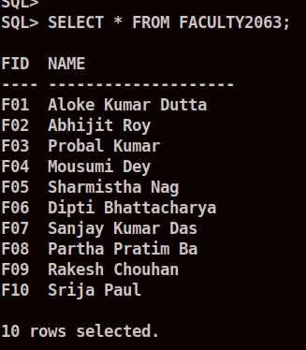

13. Insert column pass marks in subject table and add values to this column.
ALTER TABLE SUBJECT2063 ADD PASSMARKS NUMBER(3) DEFAULT 30;

UPDATE SUBJECT2063 SET PASSMARKS=40 WHERE SUBJECTCODE LIKE 'CS%' OR SUBJECTCODE='EC501';
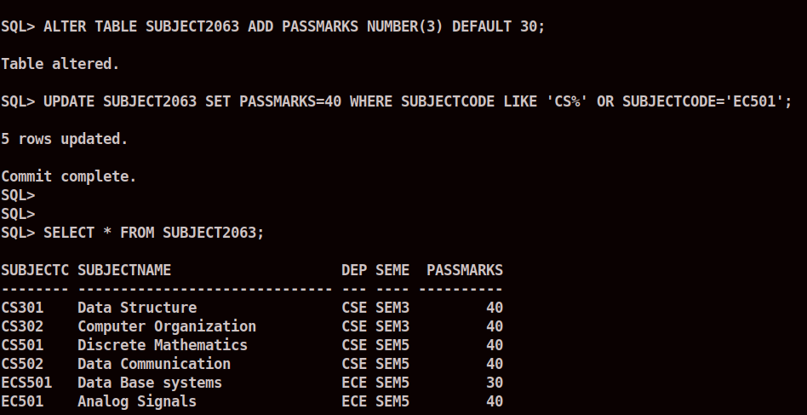

14. Delete the column pass marks from Result.
ALTER TABLE RESULT2063 DROP COLUMN PASSMARKS;
DESC RESULT2063;
